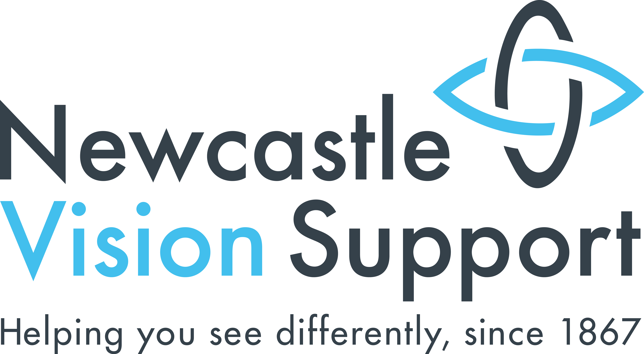
6th Floor
Hadrian House
Higham Place
Newcastle upon Tyne
NE1 8AF
Tel: (0191) 232 7292
Email: info@newcastlevisionsupport.org.uk
Newsletter
Summer 2024

Headlines

● Memberships………………………. pg 2.
● Christmas Lunch………………...… pg 2.
● Technology Service Update………. pg 3.
● Whats On……………..………………. pg 5.
…..and many more articles inside!

Useful Contact Numbers
- Newcastle Vision Support – 0191 232 7292
- Social Care Direct on 0191 278 8377
- In an emergency situation out of these hours contact the Emergency Duty Team on 0191 232 8520
- Victim First on 0800 011 3116
- Newcastle Carers on 0191 275 5060
- Always contact the police or ambulance service in an emergency on 999
- Non emergency police 101

Opening Hours
- Monday – 10am – 4.00pm
- Tuesday – Friday – 9.30am - 4-30pm

Other Formats
This newsletter is available in large print, Braille, tape and email. If you would like it in a different format please contact the office. It is much cheaper for us to send the newsletters out by email.

Registered Charity No: 115815
Company Limited by Guarantee: 5865697
Contents:
Memberships: 2
Christmas Lunch: 2
Technology Service Update: 3
Our Newsletter Is now available as a Podcast: 3
Items for Sale: 4
Charles Bonnet Support Group: 5
Touch tours at Alphabetti Theatre: 5
Whats On: 5

Memberships:
All of our membership application forms for 2024 – 2025 have now been sent out. If you have paid your membership, you should have now received your confirmation card. Please call the office if you wish to check the status of your membership. Being a member of Newcastle Vision Support means that you have access to our subsided taxi service, priority access to all our groups, unlimited support with benefits and an invitation to our annual Christmas lunch. We’d like to say a big thank you to everyone who has already paid their membership and made a kind donation.

Christmas Lunch:
We will soon be sending out information about our 2024 Christmas lunch. This year our Christmas lunch will be on Thursday 12th December. This is an event for members only. We will be sending invitations with more details out to members within the coming weeks. If you are unsure if you are a member, please call the office on 0191 232 7292 to check.

Technology Service Update:
We are pleased to report that Newcastle Vision Support now has it’s very own Alexa skill! This has been the brainchild of our Technology Office, Angus, and has been developed by BJSS who are a technology company based in Newcastle.

The skill will allow you to listen to our latest newsletter or find out about upcoming groups and events.

To try this out for yourself, simply ask Alexa to enable Newcastle Vision Support and then follow the instructions for either listening to the latest newsletter or finding out about upcoming events.

We are very grateful to BJSS and their staff for helping turning Angus’s idea into reality, as it makes accessing our newsletter and finding out about events and groups even easier.

Our Newsletter is now available as a Podcast:
As well as our Alexa Skill, you may also be interested to know our newsletter is also now available as a podcast on our website. This is available in the news section of our website and can be accessed using your computer smartphone or tablet.

Items for Sale:
Optelec Clear View C Speech:
We have a Optelec CCTV Screen Reader for sale. The device is a desktop video magnifier which is designed to improve your reading experience. Simply select your preferred reading voice, sit back, relax, and listen to documents as they are read aloud. The machine reads printed letters, newspapers, magazines and more aloud. We are looking for a donation of around £1000.00. The machine usually retails at £3500.00 so we are offering a £2500.00 discount!

The machine is 3 years old but is in immaculate condition. Key features include – a 24” HD touch screen, 1.5 to 75x magnification, 36 languages and more! If you are interested in the device, please call the office on 0191 232 7292 and speak to Jacqui. You can arrange a time to come in and try the device to see if it may be beneficial to you.

Orcam Read:
We also have an Orcam Read for sale. The Orcam Read is a handheld device designed to create an independent and effortless reading experience for people with low vision and visual impairments. You simply hold the device over what you want to read, and it will read the text out loud to you. We are open to donations for this product but please bear in mind that it usually retails at £1800.00. If you think that you might be interested in this product, please contact Jacqui on 0191 232 7292 to arrange a time to come in and have a trial.

Charles Bonnet Support Group:
We have recently trialed a monthly Charles Bonnett support group. The group takes place on the first Friday of each month from 11am – 12pm. The group meets to discuss their experiences of living with Charles Bonnet, discuss support methods and sometimes participate in research to help combat the condition. If you are interested in attending the group, please call the office on 0191 232 7292 and speak to Joanne.

Touch tours at Alphabetti Theatre:
The Alphabetti Theatre will be doing a touch tour of one of their performances called ‘The Nurses Station’ on Tuesday 24th September. The interactive touch tour will run from 6.30pm until 7.00pm and will be followed by a performance of the show. Tickets are priced from £3.00 to £15.00. If you are interested in attending, please contact the Alphabetti Theatre on 0191 261 9125, phonelines are open from 11am – 10pm Monday to Saturday.

Whats On:
All groups are held in the activity room within our office at Newcastle Vision Support.

September:
Tuesday 3rd – Chair Exercise, 12.30pm.
Thursday 5th – Walking Group, 10.30am.
Thursday 5th – Knit and Natter, 1.30pm.
Friday 6th – Charles Bonnet Support Group, 11am.
Friday 6th – Art, 1.30pm.
Tuesday 10th – Chair Exercise, 12.30pm.
Thursday 12th – Knit and Natter, 1.30pm.
Friday 13th – Creative Writing, 1.00pm.
Wednesday 18th – Sight Loss Social, 1.30pm – Wiltshire Farm Foods.
Thursday 19th – Walking Group, 10.30am.
Thursday 19th - Knit and Natter, 1.30pm.
Friday 20th - Art, 1.30pm.
Tuesday 24th - Chair Exercise, 12.30pm
Wednesday 25th – Yoga – 11.15am.
Thursday 26th - Knit and Natter, 1.30pm.
Friday 27th - Creative Writing, 1.00pm.

October:
Tuesday 1st - Chair Exercise, 12.30pm.
Thursday 3rd - Walking Group, 10.30am.
Thursday 3rd – Knit and Natter, 1.30pm.
Friday 4th – Charles Bonnet Support Group, 11.00am.
Friday 4th - Art, 1.30pm.
Tuesday 8th - Chair Exercise, 12.30pm.
Wednesday 9th – Yoga, 11.15am.
Thursday 10th – Knit and Natter, 1.30pm.
Friday 11th - Creative Writing, 1.00pm.
Tuesday 15th - Chair Exercise, 12.30pm.
Wednesday 16th – Sight Loss Social, 1.30pm.
Thursday 17th – Walking Group, 10.30am.
Thursday 17th – Knit and Natter, 1.30pm.
Friday 18th – Art, 1.30pm.
Tuesday 22nd – Chair Exercise, 12.30pm.
Wednesday 23rd – Yoga, 11.15am.
Thursday 24th – Knit and Natter, 1.30pm.
Friday 25th – Creative Writing, 1.30pm.
Tuesday 29th – Chair Exercise, 12.30pm.
Thursday 31st – Walking Group, 10.30am.
Thursday 31st – Knit and Natter, 1.30pm.

November:
Friday 1st – Charles Bonnet Support Group, 11.00am.
Friday 1st – Art Group, 1.30pm.
Tuesday 5th – Chair Exercise, 12.30pm.
Wednesday 6th – Yoga, 11.15am.
Thursday 7th – Knit and Natter, 1.30pm.
Friday 8th – Creative Writing, 1.30pm.
Tuesday 12th – Chair Exercise, 12.30pm.
Wednesday 13th – Yoga, 11.15pm.
Thursday 14th – Walking Group, 10.30am.
Thursday 14th – Knit and Natter, 1.30pm.
Friday 15th – Art Group, 1.30pm.

