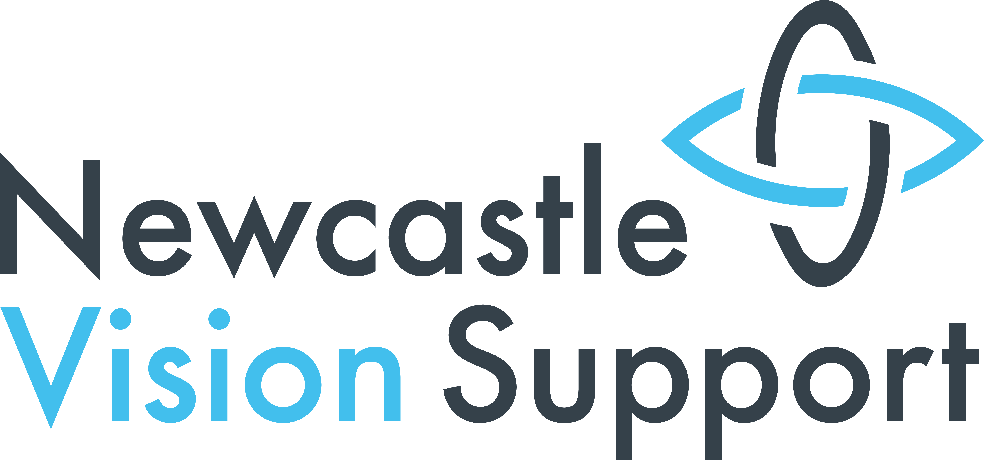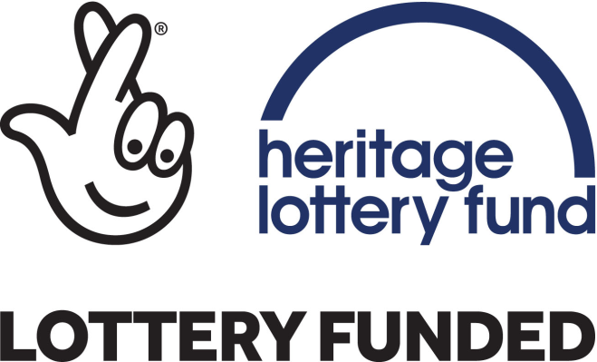
“Learn from the Past, Look to the Future “
Conference Notes 24th July 2017
Discussion Groups
The three most important areas to tackle and how we work together to do it
Group One
1 Good Signage
This needs to be at eye level
Information presented in the signage needs to be accessible
2 RNIB guidance
- Print size and font
- Clear print guidelines
3 Street Clutter
This needs to include action on pavement parking
Group Two
1 We must move on from talking and supply money to fund (social care budget)
2 Design on homes
This group focused on The Future Homes Project
- Environment
- Adaptations for existing homes - which would also have other benefits – lower energy use and affordable
3 Commitment
- Increase volunteers
- Steering Groups
- Start understanding in schools
Group Three
This group looked at a broad VI Training for care workers - Commissioning and NVS
- So a meeting has been set up between Newcastle Vision Support and Adult Services’ Commissioning
- Need to address: Lack of support to get out i.e. mobility issues, transport and safety

Group Four
Three most important areas to tackle
1 Access to artistic activities - creative outdoor activities – e.g. sky diving! Finding the resources and funding to do this
2 Perceptions /assumptions about what VI people can or want to do
3 Accessibility - public transport, transport and internal
Working Together
1 Look for collaborator
- other conditions,
- dementia and stroke
2 Use local media and messaging
- Radio stations
- Chronicle etc.
- Good stories
- Nexus at Metro Stations advertising local actions
Group Five
Three most important areas
1 Built environment and street - how new schemes are designed and pathway hazards – this requires Working together with other voluntary sector, private sector
2 Raising awareness and challenging stereotypes – include more VI people and tell people about the whole range of facilities that are available
3 Accessible Information standard
How to achieve this – working together
- Understanding the overall aim and others priorities
- Having a common aim and objectives and strength in numbers
- Campaigns link to national and local strategy
- Achievable
- Find out what is already available
- Coordination of voluntary and statutory services
Group 6
Big message from this group – accessibility benefits EVERYBODY
1 VI friendly sessions
Two main areas here
The big example was Eldon Square shopping session that used to be run but now discontinued
ACTION: NE1, FENWICKS AND JOHN LEWIS HAD BEEN INVITED TO CONFERENCE. FENWICKS AND LEWIS REPLIED. JOHN LEWIS COULD NOT COME BUT STILL INTERESTED IN WORKING WITH US – CONTACT THEM FIRST OF ALL. WE ALSO KNOW INTU HAVE ASKED FOR VI TRAINING FROM A LOCAL VI AGENCY
Age appropriate audio described performances – i.e. older people friendly performances. We know
- Live Theatre tend to have longer seasons - more time to do a Touch Tour
- AD performances at the Theatre Royal are difficult when productions have short seasons but they are already excellent in identifying performances well in advance
WORKING TOGETHER: LIVE THEATRE INVITED BUT DIDN’T REPLY TALK TO NATALIE JOYCE WHO SADLY HAD TO LEAVE BEFORE THIS SESSION
2 Tactile art and VI drama – needs to be seen as important and taken forward on a consistent and sustained basis
We talked about the example of audiobooks benefiting everyone and the growth of Audible – we need the same for tactile art!
We noted that Chris Wilson from Northumbria University had talked about 3D printing and we had in passing explored the idea of tactile maps at a meeting on our website.
ACTION: WE WNDERD WHETEHR WE COULD PICK HIS BRAINS RE THE CAPABILITY OF 3D PRINTING FOR
- Tactile facsimiles of art and architecture that everyone could experience and enjoy - the Audible effect!
- Tactile maps for the city
ACTION 2: TALK TO ROB LATHAM ABOUT THIS
ACTION 3: HANNAH SAID SHE VISITS HERE REGULARLY AS HER PARENTS STILL LIVE HERE AND WOULD LOVE TO HELP US THINK ABOUT VI AND ART/DRAMA – ANGUS TO CONTACT HER
3 Accessible Information - understanding and formats – there is still a way to go
Issues such as
- No audible information on a recent Election Broadcast
- Audio description and dual sensory loss
- Large print is of benefit to all – it should be the new norm
We also wondered about in awareness raising the targeted distribution of leaflets and information – how much gets out to GP surgeries for example?
We ran out of time on action for this one
Where to next
- Bill will pull out any common themes from the above after his holidays
- Angus will lead as the new Empowerment Officer for Newcastle Vision Support
- Arrange a follow up meeting in three months’ time
- Use the Newcastle Vision Support FB page to share ideas – Bill will continue to volunteer for this

