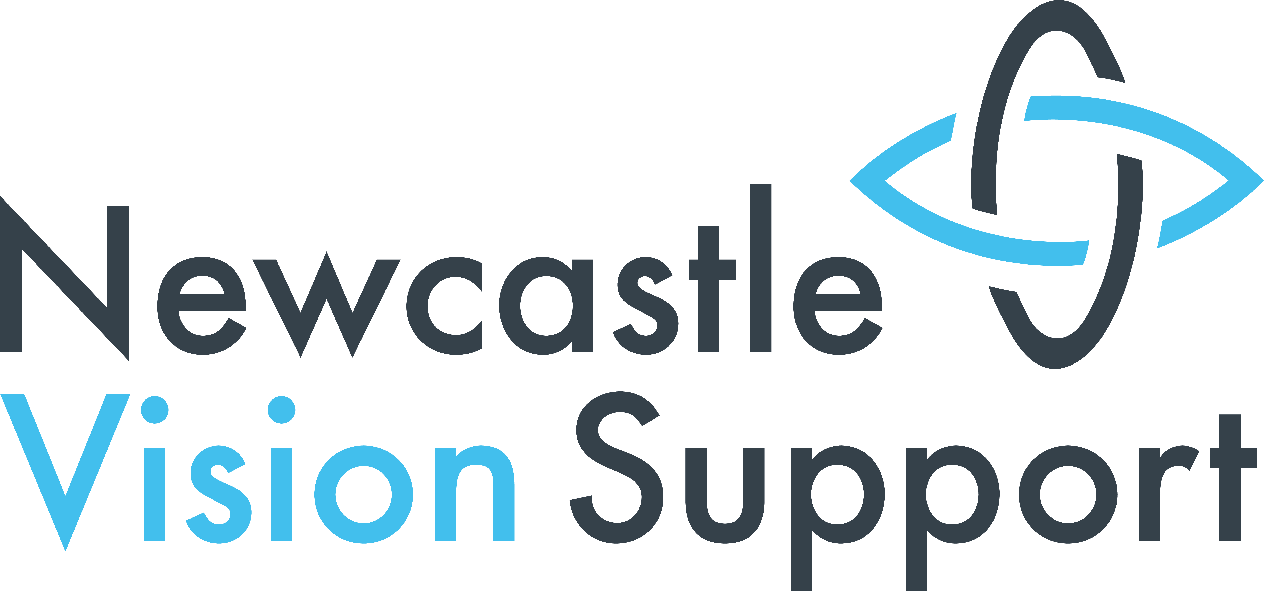

Our V.I.Story:

150 years of the

Blind Society

In Newcastle

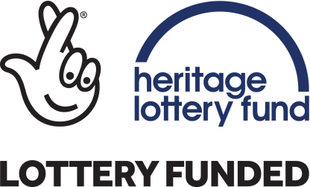

Welcome

- Newcastle Vision Support is 150 years old in 2017. This small exhibition highlights some of the most memorable events and people from our history.
- This exhibition runs for four weeks from 21st July and is financed by the Heritage Lottery Fund.
- Its content compliments a conference taking place on the 24th July, a digital archive on our new website and a book published through Tyne Bridge Publishing. Both book and archive will be launched together with our new website on 12th October - World Sight Day.
- The book will be available in standard and large print, Braille, audio on CD and we hope there will also be a Kindle version.
- The research for our anniversary has been led by visually impaired people who use our services.
- We hope you will enjoy these “tasters” of our research.

Our Former Names

Newcastle and Gateshead Auxiliary of the Society for Providing Home Teaching for the Blind – used just while we were forming in 1862

Newcastle and Gateshead Home Teaching Society for the Blind from 1867 to 1947

Newcastle and Gateshead Voluntary Society for the Blind from 1948 to 1980

Newcastle Voluntary Society for the Blind from 1980 to 1996

Newcastle Society for Blind People from 1996 to June 2017

How we started
Home teaching societies were the brainchild of Dr William Moon. As a young man he was blinded by scarlet fever. In the 1840s he developed a forerunner of Braille, the Moon Alphabet. There are still people who use Moon even now and we taught Moon classes until the early 1990s!
Dr Moon reckoned that that his alphabet, taught to blind people in their own homes, could enable them to read again and so give them back their independence making them feel part of the world again.
So he started societies across the country to spread the teaching of Moon. Dr Moon’s colleagues would visit an area, recruit a committee locally that could set up and manage a Society.
Books of the Bible were taught to start with but widened out to secular books such as “Cranford “ later on.
Moon was translated into many languages and the principle was even used to create embossed maps.
There were initial meetings to start us off in 1862 and then again in 1865 before finally getting going as Newcastle and Gateshead Home Teaching Society for the Blind in 1867 which makes one year older than the RNIB!
Before the home teaching societies there was only the Tyneside Blind Asylum, the workhouses or begging on the streets .It was a very grim existence for blind people.
When we started we only had 107 people now across Newcastle and Gateshead but now we have 1,131 people on our database in Newcastle alone but there could be as many as 7,700 people with some form of visual impairment in Newcastle and this figure is set to increase to over 8,000 in the next few years.
For our first 69 years we didn't have a permanent base instead using various meeting rooms mainly in Pilgrim Street.
Our library of moon books was housed at the Bible Society. Some books were loaned from a national library.
Founders included the Vicar and trustees of Jesmond Parish Church then recently formed itself.
Our first five presidents were the first five vicars of the church.
Other members of the early committees included knights of the realm like Sir William Haswell Stephenson and TH Bainbridge
In fact every blind person in Newcastle received a Christmas parcel of groceries from Bainbridge’s until 1944 when rationing bit hard.
Our first home teacher was Mr Jonathan Wilkinson . He was also blind and lived somewhat appropriately in Milton Street.
We always recognised the benefit of VI people getting out of the house and having social contact so we started a Friday night social night in Brunswick Hall early which people really liked.
We also started a Home Workers scheme where blind people would make products which we would sell and they would take a wage. This included making cork fenders to be hung over the side of ships to cushion the impact of bumping into other objects.
There were also tea agents and mattress makers as well as the more obvious piano tuners and knitters
A major piece of legislation was the Blind Persons Act in 1920. Provisions in the Act included:

- Specific public funds for blind welfare
- Local Authorities needed to keep a register of blind people
- A pension paid to blind people aged 50 and over

We were strengthened by this eg Our Home Teachers were increased and professionalised
See Exhibits for the Home Teachers handbook from 1934
In 1927 we produced a Diamond Jubilee handbook which told our story till then – see Exhibits for an A4 copy
In 1936, Sir Arthur Sutherland gifted us Sutherland Hall in Jesmond. This served us well as our base for the next 45 years or so. See the Exhibits for the dedication plaque.
During this time Newcastle Rotary Club funded and ran annual outings to Whitely Bay for us.
At their peak 600 people would set off from Newcastle to a send-off from the Lord Mayor and descend on the Spanish City followed by tea at the Empress Ballroom!!

The council took over the running of Home Teachers and home workers after the National Assistance Act of 1947 so we had to find a new role. Under the dynamic leadership of Mrs Harriet Pearey the society thrived once more providing craft classes, all manner of social groups, keep fit classes, a choir residential learning weekends, provision for Deafblind people and walking holidays.
Sutherland Hall sadly became unusable and we sold in 1982 .
We spent a few years at the Friends Meeting House in Jesmond and then in 1985 we moved to our present home in MEA House.
Modern times have seen a boom in the use of technology to help people and we were one of first societies to have our own IT suite.
These days we also teach people smartphones and tablets
Other innovations have been the appointment of a Safeguarding Officer in 2007 and the development of a Sensory Garden .
And the idea of going into people's homes has returned first through our Outreach services and latterly our Vision Support Workers.

Today’s services
Our aims remain true to Dr Moon’s vision
- Ensure people stay or become independent again
- Give people help when they need it
- Always keep a warm welcome

The stand at the back of this display has details of our current services
If you know someone who has a visual impairment and they need help please give us a call on 2327292

Wartime:

Hope from Horror
The terrible irony of the horrors of the 20th Century’s World Wars was that they led to many of the cornerstones of support for blind people that today we take for granted.
At the start of the First World War, Sir Arthur Pearson, the Daily Express founder who had gone blind and became Chair of the National Institute for the Blind, anticipated soldiers being blinded.
So, he set up St Dunstan’s charity (now called Blind Veterans UK) to rehabilitate blinded soldiers back into civilian life and jobs. The charity and its leaders were responsible for numerous innovations:
- Rehabilitation techniques based on “can do “positive attitudes,
- Raising the profile of blind people that helped the create the Blind Persons Act in 1920,
- Popularising the idea of open employment for blind people – not just workshops or home workers schemes, making the public aware of the wider range of occupations that blind people could do e.g. masseurs, telephonists.
- Talking books (spearheaded by Sir Arthur’s successor, Sir Ian Fraser, who became an MP)
- Free wireless for blind people that then inspired another war veteran, Sir Beechcroft Towse, to start the British Wireless for the Blind fund
- In Germany, the systematic use of dogs to guide people that happened after the First World War then eventually inspired the formation of Guide Dogs in the UK in 1931.

- Blind people were one of the groups who were offered evacuation during the Second World War but very few left Newcastle. Ironically, later the war Newcastle took blind evacuees from other areas.

- People who had previously been termed “unemployable blind “found and kept jobs as a result of the Second World War in particular.

Issues facing visually impaired people today
These include
- The likelihood of developing a visual impairment is 1 in 5 for anyone aged 75 and over and 1 in 2 for people aged 90 and over
- Social isolation
- Having multiple needs – not just visual impairment
- Information becoming predominantly online and using the digital world when one has a visual impairment
- Having information in in a format one can read. Only 3-4% of visually impaired people use Braille. The main format many people need is large print - Arial 18pt and above
- Getting around the city e.g. accessible public transport , pavement parking street clutter and inconsiderate cyclists
Councillor James Clydesdale
James Clydesdale was born in Glasgow in 1879 and lost his sight when was eight. He entered Royal Glasgow Asylum and School for the Blind and led his first strike at the age of 10 about the quality of food!

He ended being an official for the “National League of the Blind” – the blind workers trade union and came to Newcastle to set up a branch here.

He became a councillor of Stephenson Ward in 1922 and joined the Society a year later.

He was the first socialist and blind mayor of Newcastle in 1945 /6 and served as our president in his last years from 1957 until his death in 1962.

In April 2017 a plaque was erected at Benwell Library by the Lord Mayor to commemorate his life.

Speech made 1935

“Civilisation is not measured by the cleverness of its scientists or its craftsmen, but by its human relationships, the consideration it has for each of its members, the love it expresses, and the social contacts between the individuals composing its society”

Councillor James Clydesdale, first blind Mayor of Newcastle and President of the Society

1957 – 1962

