


CLARITY – Employment for Blind People

CLARITY is in the business of producing quality toiletries and cleaning products. They are different to most suppliers of these products. Why?

They do it, not only because they have all the required skills and technology, but also because it enables them to provide employment and training for disabled and disadvantaged people. This employment enables a greater degree of financial independence for employees and their families. CLARITY provides a bridge from long term unemployment to a career and support within and beyond the organisation.

One of CLARITY’s employees, Kevin Smith, was featured on the BBC show Saints and Scroungers, as an example of a “Saint”. Kevin talked about living with vision impairment and the difficulties he had adapting to everyday life, and then trying to find a job. He found out about CLARITY by chance, and is now in employment and really enjoying being part of the organisation.


“I feel empowered and enabled; the job I am doing at CLARITY is proper work with an end product. The money that I have earned, has enabled me to improve my standards of living and social life; I feel that I am at last back in society, thanks to CLARITY.” Kevin, Production Operative, CLARITY.

2014 is a special year for CLARITY as they celebrate the 160th anniversary of the founding of the organisation - a longevity that is entirely due to support from their customers.

One of the reasons many customers choose to buy from CLARITY is because every pound spent and each purchase made buying toiletries and cleaning products helps to provide jobs for disadvantaged people. Working with CLARITY means profits are continuously reinvested in the employment of blind and disabled people, and CLARITY is proud to champion the potential of employing disabled people in the workplace.

CLARITY delivers its products to a range of private and public companies and also to individual customers. You too can make your purchases more meaningful. Rather than buying products from companies which uses profits to pay shareholders, why not buy from social enterprises, where profits are used for the good of society. You can do this through the CLARITY website: www.clarityproducts.org

Customers are assured that CLARITY uses profits in this way because it has been assessed and certified with the Social Enterprise Mark. The Mark shows customers that CLARITY are a credible organisation, creating benefit to society through business. It verifies that CLARITY is true to its word, reinvesting its profits to grow the business and provide more support and work for disabled people across the UK.

Kasia Mysiak, Unit 7 Highams Park Industrial Estate, Jubilee Avenue, Highams Park, London E4 9JD

Tel 0203 078 8943 Email kasia@clarityefbp.org


“It was a pleasure working through the development process with CLARITY in order to get exactly the right product for our passengers. We are delighted with the end results.” Ross Furlong, Director, Saga Shipping Company Ltd.

The Social Enterprise Mark is a helpful visual communicator of a genuine Social Enterprise, indicating to customers and stakeholders that they are an organisation committed to running a business with a valued social mission. It helps us to bolster their position as a great business partner, supplier, manufacturer and employer of choice. The Mark shows consumers they can trust CLARITY, that buying from this organisation has a positive impact on society. CLARITY proudly displays the Social Enterprise Mark on all stationery and external communication materials.

“Having come from the private sector, I love the challenge of running a really efficient and vibrant business but even more so in an organisation like CLARITY where success is measured not just in profit but in how much positive impact you can have on society.” -
Jeremy Robinson, CEO.
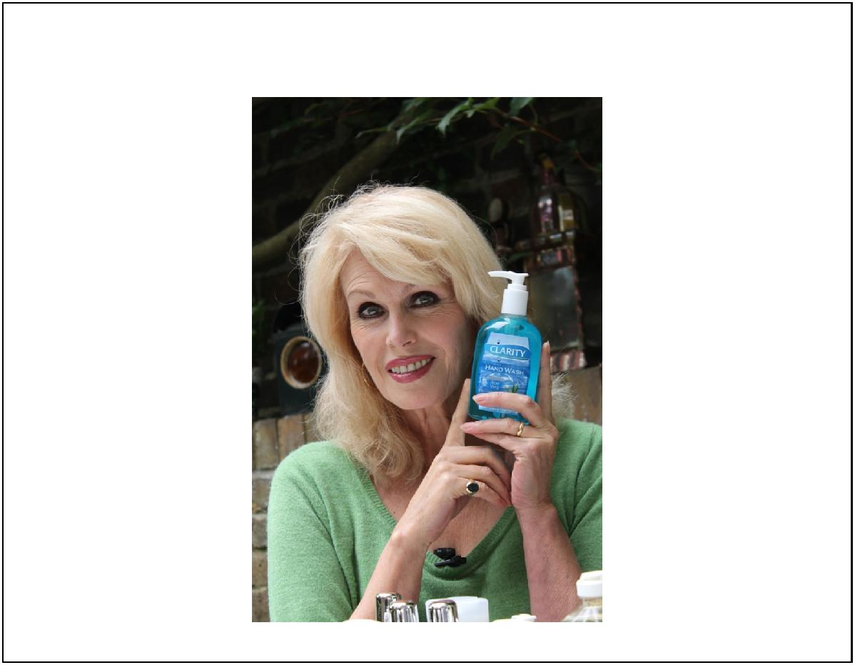

“Why buy from anyone else? CLARITY is just inspirational.” Joanna Lumley, Actor, Activist and CLARITY supporter.

Kasia Mysiak, Unit 7 Highams Park Industrial Estate, Jubilee Avenue, Highams Park, London E4 9JD

Tel 0203 078 8943 Email kasia@clarityefbp.org

