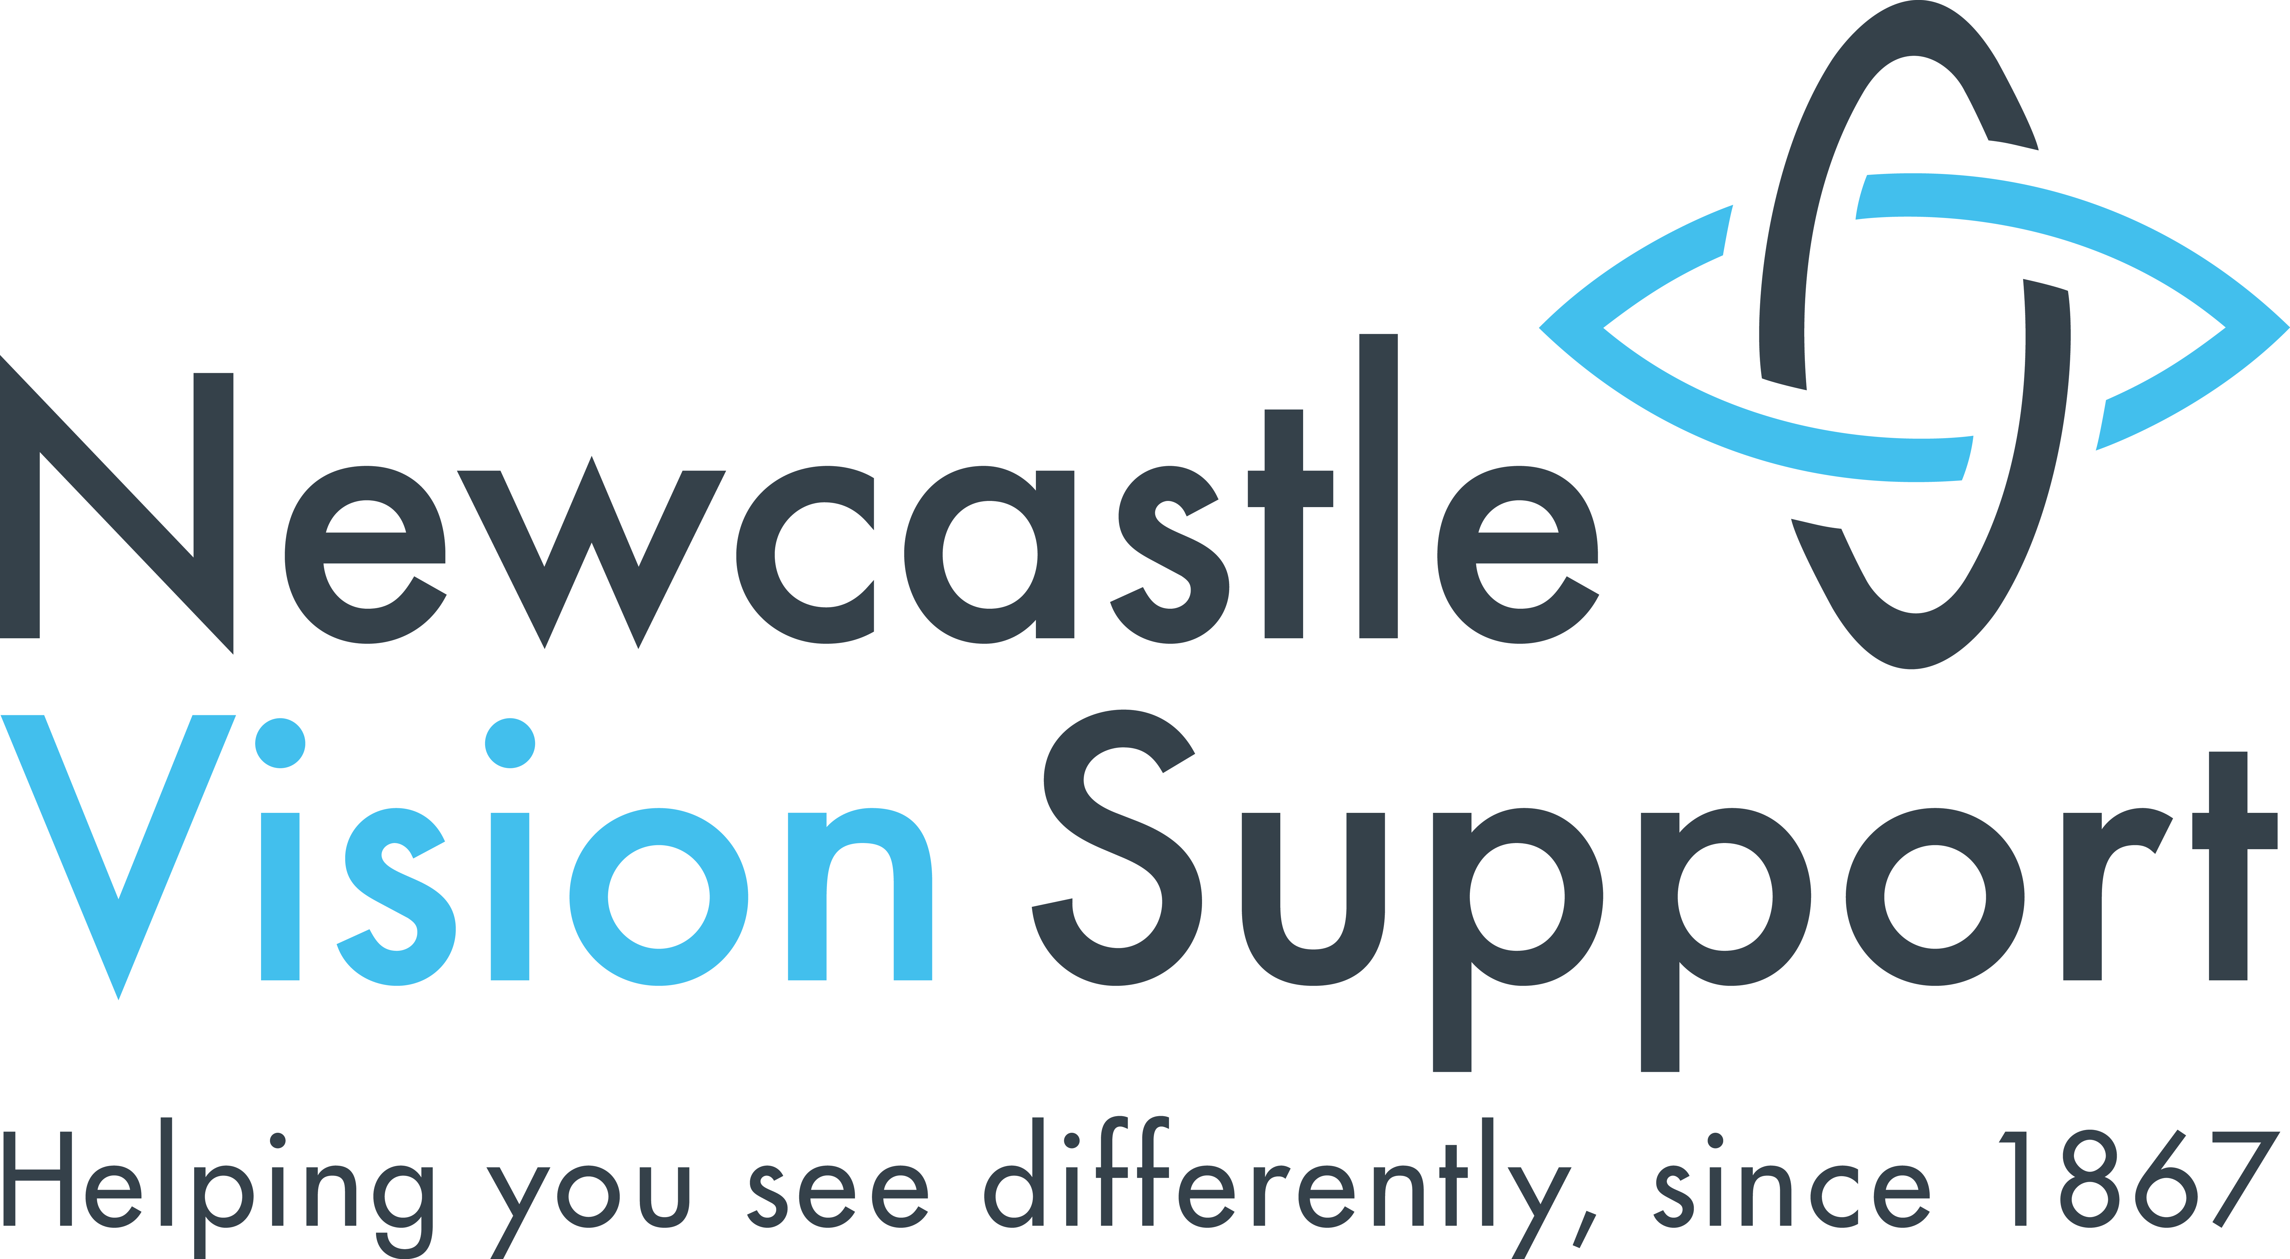
MEA House
Ellison Place
Newcastle
NE1 8XS
Tel: (0191) 232 7292
Email: info@newcastlevisionsupport.org.uk
Newsletter
Summer 2022

Headlines

● Change of staff…………………….….. Pg 3
● Taxi prices …………………………….. Pg 3
● AGM………………………………….….. Pg 4
● 155th Birthday………….…….………. Pg 5
● What’s On………………………..…. Pg 7
…..and many more articles inside!

Headlines

Add headlines last after contents page is final.

…..and many more articles inside!

Useful Contact Numbers
- Newcastle Vision Support – 0191 232 7292
- Social Care Direct on 0191 278 8377
- In an emergency situation out of these hours contact the Emergency Duty Team on 0191 232 8520
- Victim First on 0800 011 3116
- Newcastle Carers on 0191 275 5060
- Always contact the police or ambulance service in an emergency on 999
- Non emergency police 101

Opening Hours
- Monday – 10am – 4.00pm
- Tuesday – Friday – 9.30am - 4-30pm

Other Formats
This newsletter is available in large print, Braille, tape and email. If you would like it in a different format please contact the office. It is much cheaper for us to send the newsletters out by email.

Registered Charity No: 115815
Company Limited by Guarantee: 5865697
Contents

Jubilee Party 3
Change of Staff 3
Taxi Price Increase 3
Membership 4
Annual General Meeting (AGM) 4
Sponsored Ultramarathon 4
IT Support 5
NVS 155th Birthday 5
Office Closure 5
Chair Exercise Classes 6
Groups 6
What’s On 7

Jubilee Party
A big thank you to everyone who attended our Platinum Jubilee Party in May. We hope you all enjoyed it as much as we did. It was lovely to see so many familiar faces again and we raised over £350! This will contribute towards the running of the charity. Thank you to everyone who attended and made donations towards the event.

Change of Staff
Our CEO, Sue Gregg, retired in April. At present our Financial Inclusion Officer, Philippa Taylor, has stepped in as acting office manager.

Our Empowerment Officer, Angus Huntley, also left in April. We wish him all the best in his new venture.

Taxi Price Increase
As majority of you are aware taxi prices have now increased to £6.00 per journey, £12.00 for a return journey. This is due to an increase in VAT. We do aim to keep our taxi prices as low as possible. However, with the increase in fuel costs a small increase has been unavoidable. We ask you all to consider your need for the subsidised taxi service.

Membership
Thank you to everyone who has either became a member this year or has once again renewed their membership. We are currently in the process of posting out your membership cards. Thank you for any donations which you may have included along with your membership. This money will contribute to the running of our charity. As always, we are very grateful for any donations that we receive.

Annual General Meeting (AGM)
Our Annual General Meeting (AGM) will take place on Tuesday 26th July at 1.30pm in the Auditorium at MEA House. Members should have now received their invite letters and their proxy voting forms. Please note that you MUST be a paid-up member to attend our AGM.

Sponsored Ultramarathon
Nathan Davies who is the son of a one of our volunteers, Richard Davies, is completing a solo non-supported ultramarathon to raise money for Newcastle Vision Support. Nathan’s will be running 55km (34.1 miles) on Saturday 17th September 2022 around his local area.

He is asking you to sponsor him so that we can continue our vital work, helping and supporting those who are visually impaired. To read more about Nathan’s story and donate visit - https://www.justgiving.com/fundraising/nvs-55

If you would like to sponsor Nathan but are unable to access the internet there is a collection bucket and sponsorship form in the office. Please feel free to pop into the office to donate.

IT Support
We will soon be recruiting a new IT Support Assistant. If you require support surrounding technology, whether this be devices or software then please call the office to be added to the waiting list.

NVS 155th Birthday
Newcastle Vision Support turns 155 years old this year! To celebrate we are having a big birthday party on Thursday 4th August in the auditorium at MEA House. Entry to the event is £2.00 per person. Paid up members will receive a complementary strip of raffle tickets. At the event we will provide a buffet lunch and a raffle. Places are limited. Booking is essential.

Office Closure
The office will be closed from Tuesday 16th August until Friday 19th August. This is to allow for the office to be cleaned. Therefore, there will be no groups on for this week. Everything will resume as usual the following week.

Chair Exercise Class
From Friday 1st July our new Chair Exercise class will be starting. The class will run for 12 weeks from 11am – 12pm each Friday in MEA House. We have limited places so please ring the office to register your interest ASAP.

Groups

Yoga
This is a term-time group ran by a trained instructor on Wednesday morning from 11.15am - 12:30pm. The Yoga is all chair based. Please note there is a small cost of £35.00 per term for this group to cover the cost of an instructor.

Macular and CU Wednesday Groups
Our Mac group continues to run every third Wednesday of each month. The CU Wednesday is the final Wednesday of each month. Keep an eye out for your monthly letters for the groups regarding speakers and topics.

Knit and Natter
Our brilliant Knit and Natter group meet weekly to chat and craft over a cup of tea and biscuits. Thursdays 1:30pm – 3:30pm.

Art Group
The Art Group meet every other week on Friday afternoons, 1:30pm – 3:00pm. We engage in lots of different activities such as clay, papier mache, collage, needlecraft and much more! From time to time we may ask for a donation towards materials. We will also occasionally visit art galleries and museums.

As always, we will kindly ask for a donation towards refreshments during the social groups. If you are interested in ANY of these groups, or know of anyone who would like to volunteer for our social groups, please contact Beth on 0191 232 7292 or email beth@newcastlevisionsupport.co.uk

What’s On

July:
● Wednesday 20th July - Mac Group – Glaucoma UK – Rooms 5 and 6, Fifth Floor, MEA House - 1.30pm.

● Tuesday 26th July – AGM – Auditorium, MEA House – 1.30pm.

● Wednesday 27th July – CU Wednesday – Equipment Demonstration Afternoon – Rooms 2,3 and 4, Fifth Floor, MEA House – 1.30pm.

August:
● Thursday 4th August - NVS 155th Birthday Party – Auditorium, MEA House – 1.30pm. Booking is essential. £2.00 entry.

September:
● Wednesday 21st September – Mac Group – Rooms 5 and 6, Fifth Floor, MEA House – 1.30pm.

● Wednesday 28th September – CU Wednesday – Auditorium, MEA House – 1.30pm.

